

| **TITLE: Project Plan document for** Mini Project |
| --- |

**AIM:** To learn and understand the way of developing the software by classical methods of software Engineering., Planning and monitoring of the project using tools and prepare a document for the same by using the concept of software engineering **______________________________________________________________________**

**Expected OUTCOME of Experiment:** Analyze the software requirements and Model the defined problem with the help of UML diagram.

**_____________________________________________________________________**

**Books/ Journals/ Websites referred:**

1. Roger Pressman, Software Engineering: A practitioners Approach, McGrawHill, 2010 ,6th edition

2. Ian Somerville , Software Engineering , Addison Wesley,2011,9th edition

1. http://en.wikipedia.org/wiki/Software_requirements_specification

**_____________________________________________________________________**

**,Software Project Management Plan**

**for**

***E-learning website***

***Nidhi Bhanushali,Chaitanya Chaniyara,Rushabh Gandhi***

***20/09/2021***

| **Version** | **Release Date** | **Responsible Party** | **Major Changes** |
| --- | --- | --- | --- |
| 0.1 | 20/09/2021 | Chaitanya, Rushabh, Nidhi | Initial Document Release for Comment |
|  |  |  |  |
|  |  |  |  |
|  |  |  |  |
|  |  |  |  |
|  |  |  |  |

Table of Contents

| **Sr No.** | **Title** |
| --- | --- |
| **1** | **Introduction**   1. Project Overview 2. Project Deliverables 3. Evolution of the SPMP 4. Reference Materials |
| **2** | **Project Organization**   1. Process Model 2. Organizational Structure 3. Organizational Interfaces 4. Project Responsibilities |
| **3** | **Managerial Process**   1. Assumptions, dependencies and constraints 2. Risk Management 3. Monitoring and Controlling Mechanism 4. Staffing Approach |
| **4** | **Technical Process**   1. Methods, tools and techniques 2. Software documentation 3. User Documentation |
| **5** | **Work Packages, Schedule and Budget**   1. Work Packages 2. Dependencies 3. Resource Requirements 4. Schedule |
| **6** | **Additional Components**   1. Index 2. Appendices |

1.  Introduction

This section of the SPMP provides an overview of the project.

This project focuses on developing an E-learning website that provides facility to institute and students in a manner that the learning, evaluation; assessment do not remain limited to the four walls of a classroom. This website works by finding new ways to make an institute a center of excellence in education by providing all the study material, exams available to students online. The students belonging to different places, unable to attend regular classes get access to educational courses across a wide range of programs. It provides a facility for students to communicate with faculty regarding academics

1.1  Project Overview

This will mainly be used by distance education programs offered by institutes, in order to enable students to get the academic facilities from any computer connected to the Internet. This website will be designed in a way that it can be easily extended to provide more features and will be easily customizable so that it can work according to every potential user.All the information including course details, fee structure and notices for students will also be displayed on the site

1.2  Project Deliverables

(List the primary deliverables for the customer, the delivery dates, delivery locations, and quantities required satisfying the terms of the project agreement.)

* User manual
* User guide video
* Srs document
* Testing document.
* Code files of project.

The application will be available as a web application that can be accessed from web browsers.

The user will just require a stable internet connection and have an account in order to view the contents.

**Operating Environment**

* PCs running Windows operating system
* Macs running OS X Panther (v10.3)
* iPads running iPadOS 13.0 or later.
* Android-based Tablets running on (v4.2) jelly bean

The application will be available as a web application that can be accessed from anywhere via the web browser.

**Web Browser support:**

● Firefox

● Google Chrome

● Edge

● Safari

1.3  Evolution of the SPMP

The Agile - Scrum software development methodologywill be followed for this project. Hence, the various functionalities of the project have been divided into sprints and each sprint has a definite schedule. If a sprint isn’t completed on time, then the unfinished product backlog item will be rolled forward for completion in the next agile sprint which is known as overflow.

In agile, being able to pivot and make changes to big organizational changes on the fly is key to long-term success, but so is the ability to do so with a consistent underlying purpose. Change management is concerned with controlling and tracking changes to project and product scope and ensuring conformance to customer expectations. Agile change management is concerned with increasing the ability of the project to be responsive to requests for change and to quickly implement the accepted change requests. Any changes that need to be made, will be incorporated in the upcoming sprints. Carrying out scheduled updates will not be a difficult task since its schedule and the corresponding sprint (wherein the update will be implemented) will be decided beforehand. Moving on to unscheduled updates, an employee might come up with an alternative and a better solution for any sub-problem. This idea will be pitched to the whole team and if the majority of the members approve of this idea, then the project manager will verify and integrate this to the system. In case of a tie, the project manager’s say is final. The sprint wherein this unscheduled update will be incorporated, will be dependent on the type and purpose of the update.

1.4  Reference Materials

* <https://www.udemy.com/join/login-popup/?next=/home/my-courses/learning/%3Fp%3D1%26progress_filter%3Dcompleted>
* <https://www.edx.org/course/programming-for-everybody-getting-started-with-pyt>
* <https://www.coursera.org/professional-certificates/sas-programming?utm_source=gg&utm_medium=sem&utm_campaign=37-SAS-Programmer-IN&utm_content=37-SAS-Programmer-IN&campaignid=12737601544&adgroupid=123746533387&device=c&keyword=coursera%20programming&matchtype=b&network=g&devicemodel=&adpostion=&creativeid=514091947388&hide_mobile_promo&gclid=CjwKCAjwndCKBhAkEiwAgSDKQc17Bz9z_2IEm6o3_Ke_iKA-bG8e7uaCauj23gWjCZXg4_ExxN1mYBoCiv0QAvD_BwE>

1.5  Definitions and Acronyms

**Scrum master:** Scrum Master is responsible for promoting and supporting Scrum. Scrum Masters do this by helping everyone understand Scrum theory, practices, rules, and values.

**Product Owner:** The Product Owner (PO) is a member of the Agile Team responsible for defining Stories and prioritizing the Team Backlog to streamline the execution of program priorities while maintaining the conceptual and technical integrity of the Features or components for the team.

**Scrum Development Team:** Scrum Development Team consists of professionals who do the work of delivering a potentially releasable Increment of “Done” product at the end of each Sprint. A "Done" increment is required at the Sprint Review. Only members of the Development Team create the Increment.

2.  Project Organization

This section specifies the process model for the project and its organizational structure.

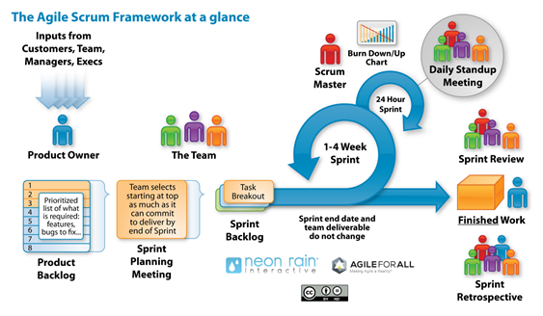

2.1  Process Model

## Agile scrum methodology is sprint-based project management system whose goal is to deliver the highest value to stakeholders.

● Scrum is a framework that allows for more effective collaborations among teams working on complex projects.

● Agile and scrum are two similar project management systems with a few key differences.

● Agile is more flexible and promotes leadership teams, while scrum is more rigid and promotes cross-functional teams.

Agile scrum methodology is a [project management system](https://www.businessnewsdaily.com/9977-best-online-project-management-software.html) that relies on incremental development. Each iteration consists of two- to four-week sprints, where each sprint's goal is to build the most important features first and come out with a potentially deliverable product. More features are built into the product in subsequent sprints and are adjusted based on stakeholder and customer feedback between sprints.

Whereas other project management methods emphasize building an entire product in one iteration from start to finish, agile scrum methodology focuses on delivering several iterations of a product to provide stakeholders with the highest business value in the least amount of time.

[Agile scrum methodology](https://www.businessnewsdaily.com/15892-project-management-styles.html) has several benefits. First, it encourages products to be built faster, since each set of goals must be completed within each sprint's time frame. It also requires frequent planning and goal setting, which helps the scrum team focus on the current sprint's objectives and increase productivity.

Entry criteria for our model are requirements gathering, project definition and risk assessment. Exit criteria are delivery of products that customers can assess, maintenance and addition of new features in future sprints. Teams work separately on different tasks and the modules are merged together in the end.

2.2  Organizational Structure

Kindly check out the Gantt Chart: Section 5.5 -Page __

2.3  Organizational Interfaces

Describe the administrative and managerial interfaces between the project and the primary entities with which it interacts.   A table may be a useful way to represent this.

*Note:* Dummy data and names are provided

| **Organization** | **Liaison** | **Contact Information** |
| --- | --- | --- |
| Customer: KJ Somaiya | Willie J Vazquez | 731-781-2630  ecmru8l2wx@gmail.com |
| Subcontractor: | Jermaine K Coughlan | 601-300-7940  lmchdvt6lar@gmail.com |
| Software Quality Assurance | Rushabh Gandhi  Nidhi Bhanushali  Chaitanya | [rushabh.dg@somaiya.edu](mailto:rushabh.dg@somaiya.edu)  [nbb1@somaiya.edu](mailto:nbb1@somaiya.edu)  c.chaniyara@somaiya.edu |
| Software Configuration Management | Rushabh Gandhi  Nidhi Bhanushali  Chaitanya | [rushabh.dg@somaiya.edu](mailto:rushabh.dg@somaiya.edu)  [nbb1@somaiya.edu](mailto:nbb1@somaiya.edu)  c.chaniyara@somaiya.edu |

Table F-1. Project Interfaces

2.4  Project Responsibilities

Identify and state the nature of each major project function and activity, and identify the individuals who are responsible for those functions and activities.  Tables of functions and activities may be used to depict project responsibilities.

| **Role** | **Description** | Person |
| --- | --- | --- |
| Project Manager | leads project team; responsible for project deliverables | Rushabh Gandhi |
| Technical Team Leader(s) | Represents the  development team  and manages product backlog | Nidhi Bhanushali |
| Development Team | Overall product development | Chaitanya |

Table F-2.  Project Responsibilities.

3.  Managerial Process

This section of the SPMP specifies the management process for this project.

3.1  Management Objectives and Priorities

| **Project Dimension** | **Fixed** | **Constrained** | **Flexible** |
| --- | --- | --- | --- |
| Cost |  |  | X |
| Schedule |  | X |  |
| Scope (functionality) |  |  | X |

Table F-3: Flexibility Matrix

3.2  Assumptions, Dependencies, and Constraints

* We have assumed that the user will have a high bandwidth internet connection in order to stream or download videos.
* Supported mobile OS are Android 4.2+ and iOS.
* Supported web browsers for desktop are Chrome, Firefox, Edge and Safari.

3.3  Risk Management

Customer data or production data of any sort is put in distributed databases such as Apache Cassandra, where each data element is replicated multiple times in production, and then we generate primary backups of all the data into AWS S3 (Amazon’s Simple Storage Service). All the logical errors, operator errors, or software bugs, many kinds of corruptions can be rectified using these S3 backups. A global backup is also kept in Google Cloud Storage and on archival storage like tape.

3.4  Monitoring and Controlling Mechanisms

| **Information Communicated** | **From** | **To** | Time Period |
| --- | --- | --- | --- |
| Status report | Technical leader | Project Manager | Weekly |
| Status report | Development Team | Project Manager | Weekly |
| Project Review | Project Manager, Technical Leader | Customer | Monthly |

Table F-4: Communication and Reporting Plan

Table F-4: Communication and Reporting Plan

3.5  Staffing Approach.

The skills required for the project would be:

· Knowledge about Databases

· Node framework and JavaScript programming language

· UI/UX designing skills

· Good Communication skills

The team members will be recruited based on which part of the project they would like to work in along with what knowledge they have and how willing they are to learn more not only what’s in scope but what’s outside the scope as well.

They will also be selected on how well they can communicate with people in their team as well as with people from different teams and organizations

They will be provided with resources like YouTube playlists ,documentations etc to expand their knowledge further.

4.  Technical Process

4.1  Methods, Tools, and Techniques

This project will be available as a web application and a mobile application as well.

**Technologies required for the web application:**

* HTML
* CSS
* Bootstrap
* Javascript and Jqeury
* Django

**Database:**

* Postgresql
* sqlite3

**Application and data:**

* Python
* Javascript

**Architecture and other development practices and the required technologies for them:**

* DevOps
* Dockers

**Business tools:**

* GSuite

4.2  Software Documentation

Software documentation is a part of any software. Good documentation practices are important for the success of the software. Documentation must comprise an interactive User Experience, Information Architecture, and good understanding of your audience.

It needs to serve the purpose of resolving the issues, when encountered by the developer, end user or while the customer is facing the knowledge Base.

Appropriate details and description need to be in the documented to achieve the following goals:

· Resolve issue encountered by the developer during the development process

· Help end-user to understand the product

· Assist customers and the support team to find the information.

**4.2.1 Software Requirements Specification (SRS)**

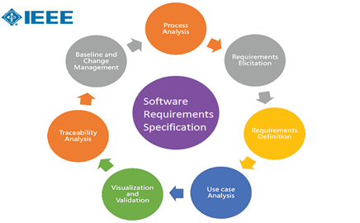

[**Link to the srs document**](https://drive.google.com/file/d/1d4-0QQh_dPJzooG6Cw1-b0siIdmNo6Pe/view?usp=sharing)

4.2.2  Software Design Description (SDD)

Database:

* Postgresql
* sqlite3

Architecture and other development practices and the required technologies for them:

* DevOps
* Dockers

4.2.3  Software Test Plan

Unit testing will be followed here, where each module or component created by a developer, will be tested rigorously by other 2. Since we are following the agile-scrum model, and in every sprint a new component is developed, these sprints can be tested individually. Also, there will be separate sprints for aggregating and integrating the components that have been developed individually.

In addition, performance and stress testing will be used to ensure the smooth working of the system.

4.3  User Documentation

The User Documentation will be in the form of a video tutorial so it is easy for students to become familiar with the application.

A paper documentation of the same will be available if someone wishes to delve deeper and understand more about the application

4.4  Project Support Functions

The project follows standard procedures which are updated as and when new modules are added. The transactions for the database are carried out as per ACID properties, that is atomicity, consistency, isolation and durability.

5.  Work Packages, Schedule, and Budget

5.1  Work Packages

The web application will have 2 packages:

* Backend: Postgresql
* Frontend: HTML, CSS, JS, Jqeury, Django.

5.2  Dependencies

Cloud computing service

* For storing the videos and the study material provided by the faculties.
* For storing student data.
* For storing faculty data

Mobile

* Active Internet Connection.

5.3  Resource Requirements

Roles:

* Scrum master
* Product Owner
* Development team

Hardware and software requirements:

* Laptops/PCs with intel i5 processors.
* Text editors like VsCode, Sublime text or Vi
* Private GitHub account

Time requirements: Approximately 1 year

5.4  Budget and Resource Allocation

Budget has been calculated using the COCOMO II model in Exp2.

5.5  Schedule

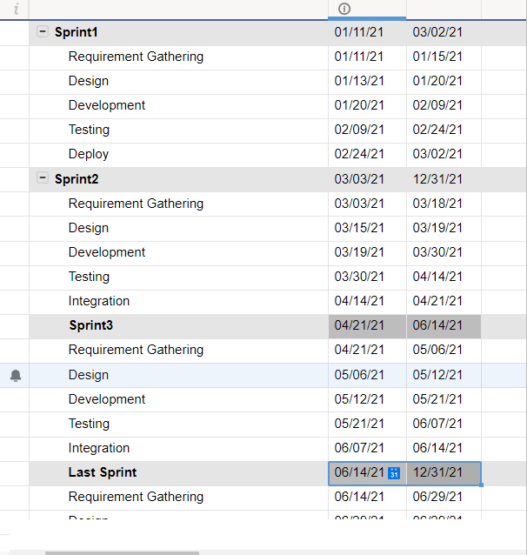

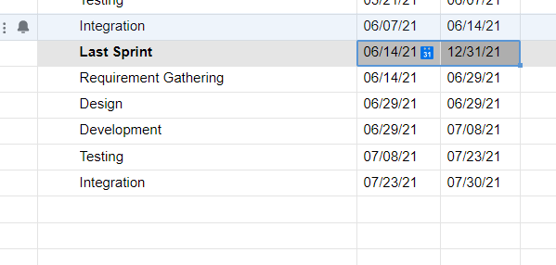

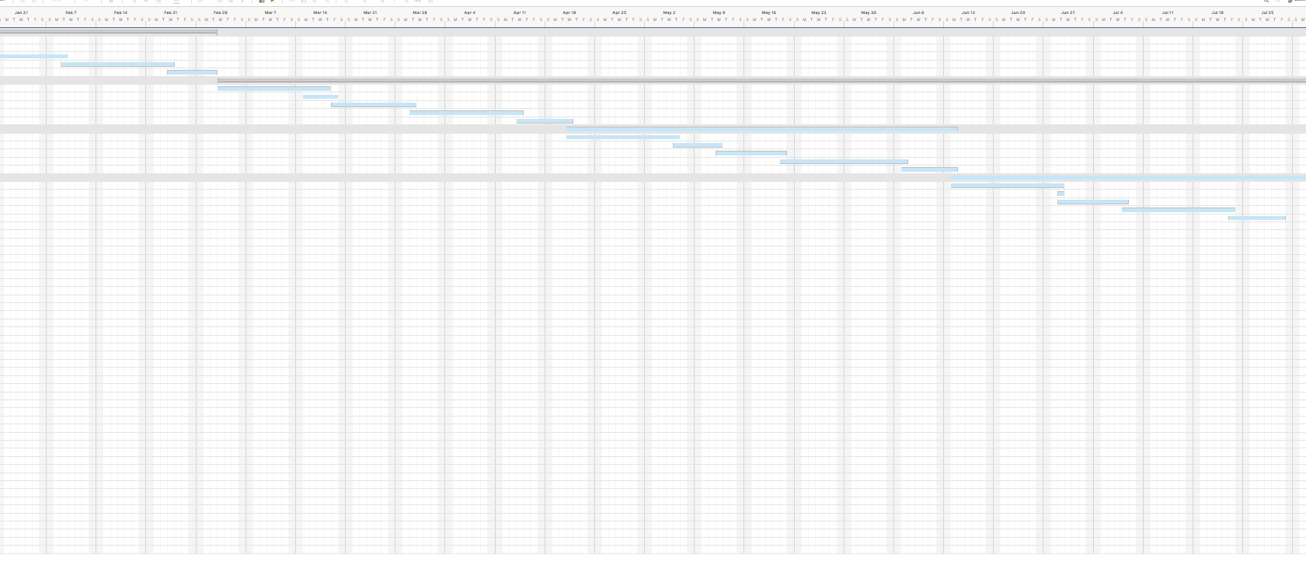

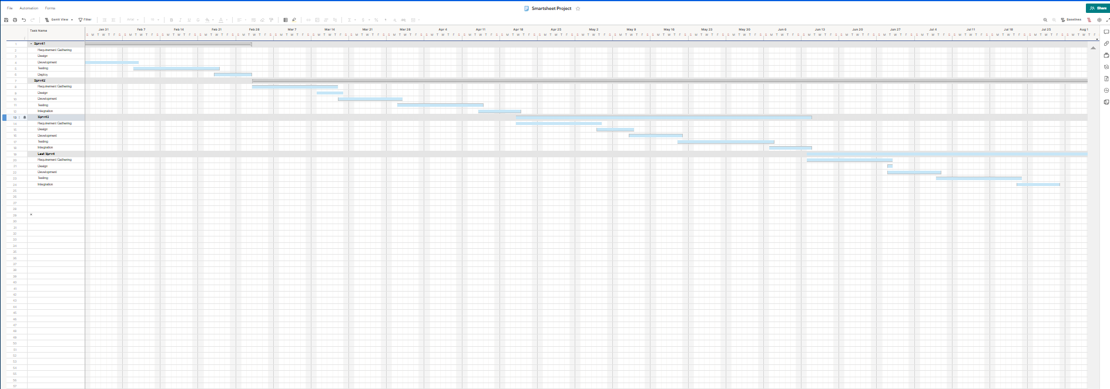

6.  Additional Components.

Certain additional components may be required and may be appended as additional sections or subsections to the SPMP. Additional items of importance on any particular project may include subcontractor management plans, security plans, independent verification and validation plans, training plans, hardware procurement plans, facilities plans, installation plans, data conversion plans, system transition plans, or the product maintenance plan.

6.1 Index.

· HTML- HyperText Markup Language

· JS- Javascript

· CSS- Cascading Style Sheets

· SQL - Structured Query Language

**Conclusion: Thus by doing this experiment we successfully prepared our project plan.**

**Post Lab Descriptive Questions**

1. State various Scheduling principles and explain them in detail.

